**Practices - Section 6**

**Problem 1: Validate a Bank PIN**

Overview

Develop a java program to validate bank PIN of a customer. Use a while loop to repeat code until a valid PIN is entered.

Task

1. Declare a valid integer PIN.

2. Prompt the user to enter the PIN.

3. In a while loop, perform the following steps:

• Compare the user-entered PIN with the already declared PIN

• If the entered PIN is not the same, prompt the user to enter the PIN again

• Repeat the loop until the correct PIN is entered

4. Print a message confirming that the correct PIN has been entered and that the user now has access to their account.

The ValidatePin.java file is available to help you get started

**Coding:**

import java.util.Scanner;

public class ValidatePin {

public static void main(String[] args) {

Scanner scanner = new Scanner(System.in);

// Declare a valid integer PIN

final int VALID_PIN = 1234; // You can set this to any valid PIN

// Prompt the user to enter the PIN

System.out.print("Enter your PIN: ");

int enteredPin = scanner.nextInt();

// Use a while loop to validate the entered PIN

while (enteredPin != VALID_PIN) {

System.out.println("Invalid PIN. Please try again.");

System.out.print("Enter your PIN: ");

enteredPin = scanner.nextInt();

}

// Print a message confirming that the correct PIN has been entered

System.out.println("Correct PIN entered. You now have access to your account.");

scanner.close();

}

}

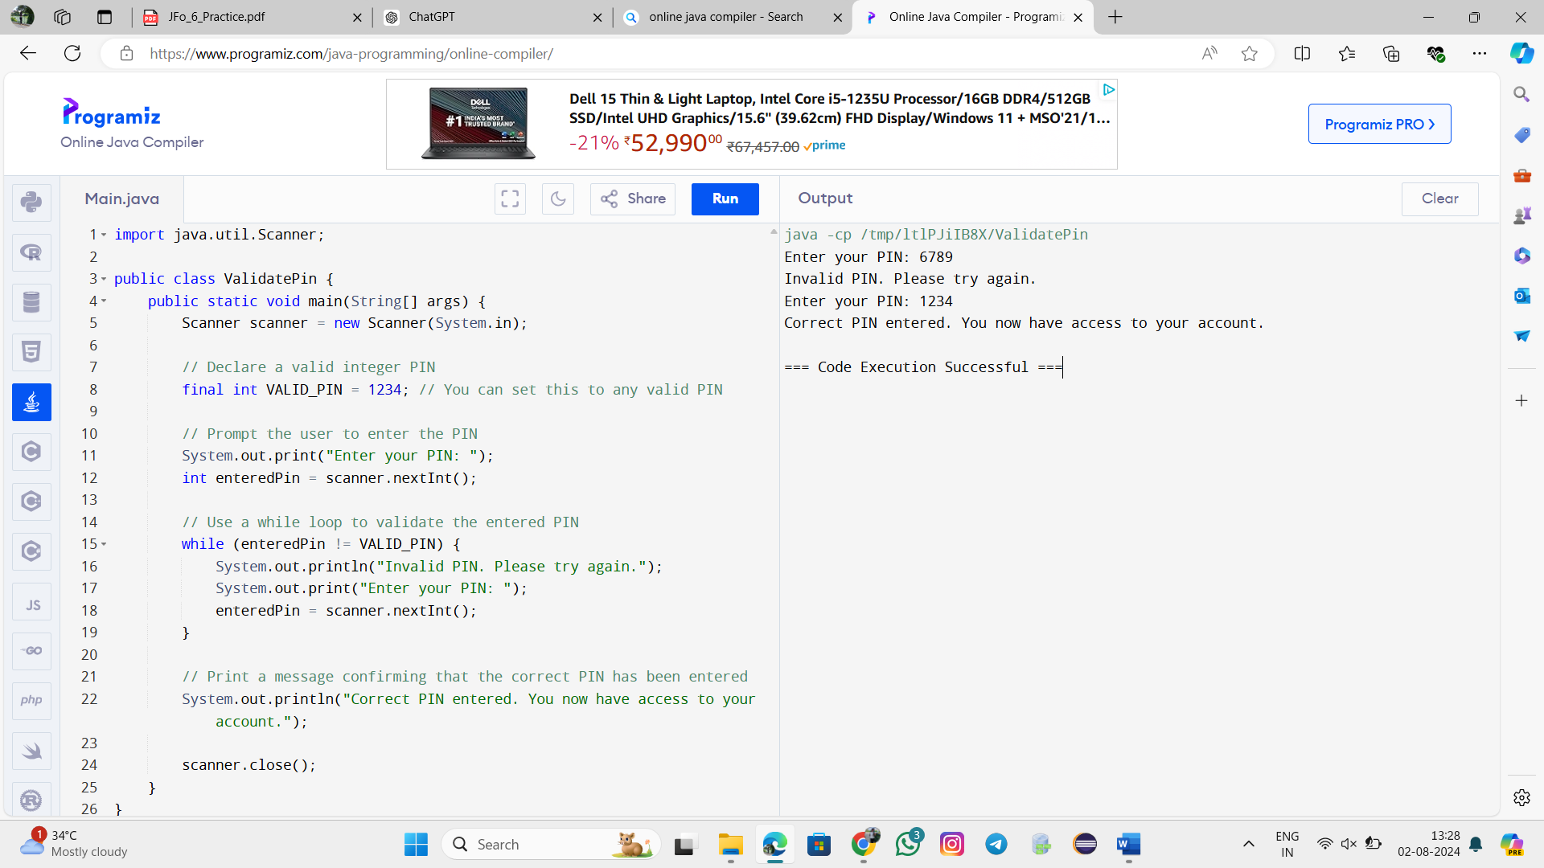

**Problem 2: Displaying Multiples of a Number:**

Overview

Develop a java program to calculate the multiples of a given number using a for loop.

Task

Have the user enter a number, and then use a for loop to display all the multiples of that number from 1 to 12.

Expected Output:

Choose a number: 7

7x1 = 7

7x2 = 14

7x3 = 21

7x4 = 28

7x5 = 35

7x6 = 42

7x7 = 49

7x8 = 56

7x9 = 63

7x10 = 70

7x11 = 77

7x12 = 84

The DisplayMultiples.java file is available to help you get started.

**Coding:**

import java.util.Scanner;

public class DisplayMultiples {

public static void main(String[] args) {

Scanner scanner = new Scanner(System.in);

// Prompt the user to enter a number

System.out.print("Choose a number: ");

int number = scanner.nextInt();

// Use a for loop to display all the multiples of the number from 1 to 12

for (int i = 1; i <= 12; i++) {

System.out.println(number + "x" + i + " = " + (number * i));

}

scanner.close();

}

}

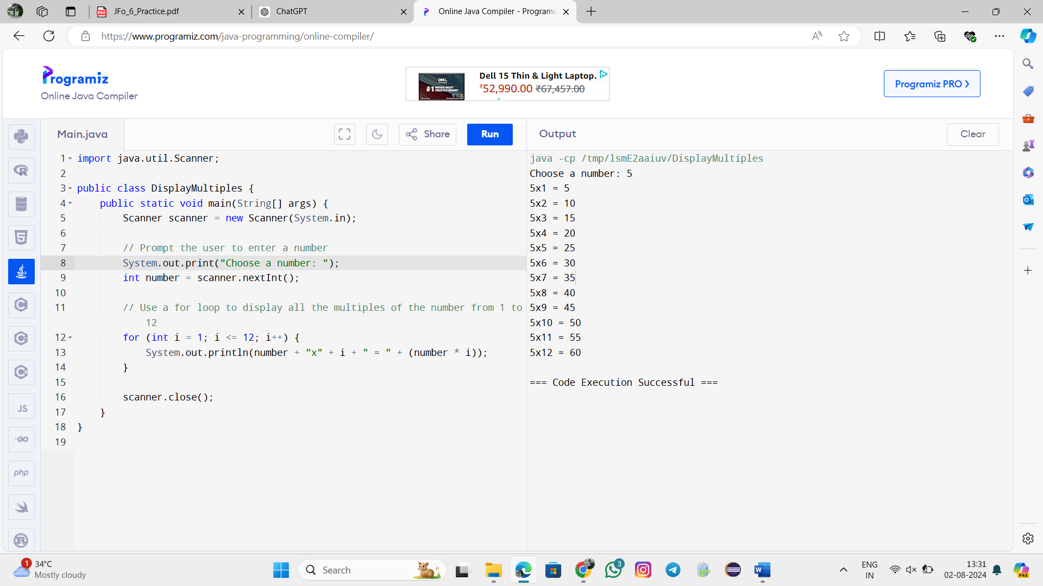

**Problem 3: Programmatic ASCII Art:**

Overview

Using text to create a picture is known as ASCII art. In section 2, we made an ASCII art cat. This required us to type every character in

the art we wanted to create. In this practice, you’ll find a way to draw basic shapes programmatically in customizable sizes.

5x4 Rectangle

5x5 Isosceles Right Triangle

Task

Complete the following two methods in LoopShape.java:

• createRectangle(): This method accepts two arguments for width and height which should be used to print a rectangle

• createTriangle(): This method accepts one argument for the size of a leg, which should be used to print an isosceles

right triangle

Try changing the value of the arguments you’re supplying these two methods from the main method. Make sure your program can

successfully draw each shape to a custom size. Additionally, your program must:

• Refuse to draw shapes with any dimension less than 1

• Be able to draw shapes with any dimension equal to 1 (a 1x1 shape should print just a single character)

If the problem seems difficult, remember to break it into smaller challenges such as:

• How do I print a single line that is a variable number of “#” characters wide?

• How do I create a String that begins and ends with a “#”, but has a variable number of spaces in between?

Finishing each smaller challenge is an accomplishment. This problem is as much about understanding loops as it’s about

understanding how to break a big problem into smaller tasks.

The knowledge you’ve gained in this section on loops will be very helpful in completing this program. You’re free to use whichever type

of loop statements you feel would be best. You’ll also need to remember a few concepts from previous sections.

The LoopShape.java and LoopShapeTest.java files are available to help you get started

**Coding:**

import java.util.*;

public class GeeksForGeeks {

public static void printPattern(int n)

{

int i, j;

for (i = 0; i < n; i++) {

for (j = 0; j < n; j++) {

if (i == 0 || j == 0 || i == n - 1

|| j == n - 1) {

System.out.print("#");

}

else {

System.out.print(" ");

}

}

System.out.println();

}

}

public static void main(String args[])

{

int n = 6;

printPattern(n);

}

}

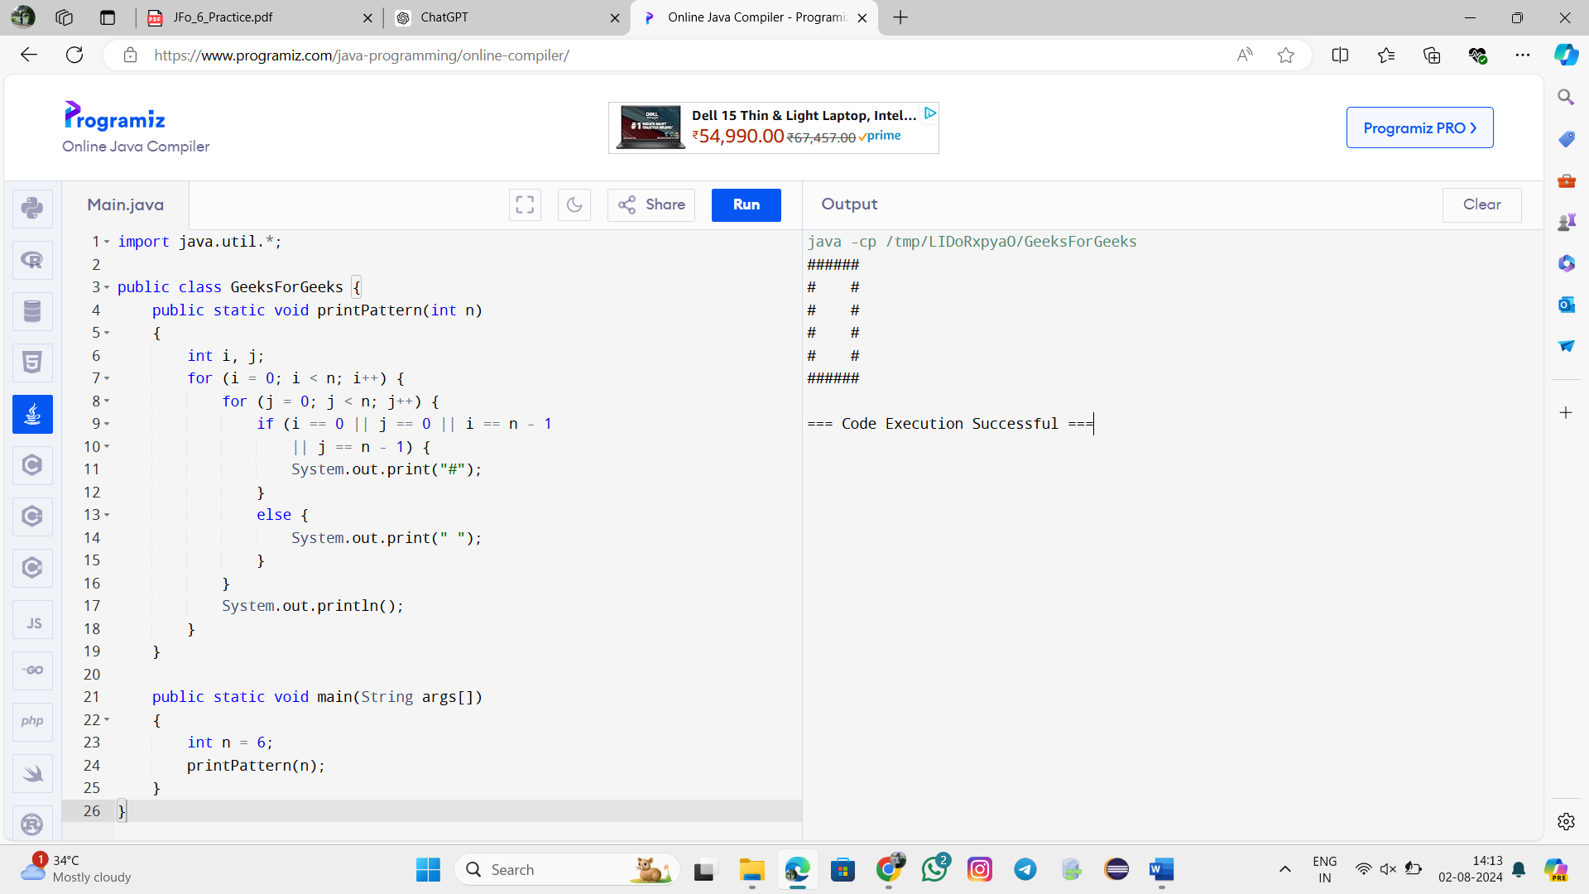

import java.util.Scanner;

public class Hollowtangle{

public static void main(String[] args){

int my_input, k, i, j;

Scanner my_scanner = new Scanner(System.in);;

System.out.print("Enter the size : ");

my_input = my_scanner.nextInt();

for( i=1;i<=my_input;i++){

if(i==1 || i==my_input)

for( j=1;j<=i;j++){

System.out.print("#");

} else {

for( j=1;j<=i;j++){

if(j==1 || j==i)

System.out.print("#");

else

System.out.print(" ");

}

}

System.out.println();

}

}

}

